 | Student Name: Sanika Krushna Bhagat | Class: MCA-I
 | Program Title: | Date:
 | Remark:
Q1. | Write a python program for to implement the sparse matrix.  r=int(input("Enter the number of rows:")) c=int(input("Enter the number of columns:")) m=[]  print("Enter the first matrix:") for i in range(r):  l=[]  for j in range(c):  num=int(input("Enter the element:")) l.append(num)  m.append(l)  print("Display the matrix:") for i in m:  print(i,end="\n")  r1=[]  c1=[]  val=[]  for i in range(r): for j in range(c):  if m[i][j]!=0: r1.append(i) c1.append(j) val.append(m[i][j])  print("Saprse matrix:") print("Rows=",r1) print("columns=",c1) print("value=",val)

Output:
Enter the number of rows:3 Enter the number of columns:3 Enter the first matrix:
Enter the element:10 Enter the element:0 Enter the element:0 Enter the element:0 Enter the element:20 Enter the element:0 Enter the element:0 Enter the element:0 Enter the element:0 Display the matrix: [10, 0, 0]
[0, 20, 0]
[0, 0, 0]
Saprse matrix: Rows= [0, 1]
columns= [0, 1]
value= [10, 20]

 | Student Name: Sanika Krushna Bhagat | Class: MCA-I
 | Program Title:Addition Of Sparse matrix | Date:
 | Remark:
Q2. | Write a python program to find the addition of sparse matrix element.  r=int(input("Enter the number of rows:")) c=int(input("Enter the number of columns:")) m=[]  print("Enter the first matrix:") for i in range(r):  l=[]  for j in range(c):  num=int(input("Enter the element:")) l.append(num)  m.append(l)  print("Display the matrix:") for i in m:  print(i,end="\n")  r1=[]  c1=[]  val=[] s=0  for i in range(r): for j in range(c):  if m[i][j]!=0: r1.append(i) c1.append(j) val.append(m[i][j]) s=s+m[i][j]  print("Saprse matrix:") print("Rows=",r1) print("columns=",c1)

print("value=",val) print("Addition=",s)

Output:
Enter the number of rows:3 Enter the number of columns:3 Enter the first matrix:
Enter the element:1 Enter the element:0 Enter the element:0 Enter the element:4 Enter the element:8 Enter the element:0 Enter the element:0 Enter the element:0 Enter the element:6 Display the matrix: [1, 0, 0]
[4, 8, 0]
[0, 0, 6]
Saprse matrix: Rows= [0, 1, 1, 2]
columns= [0, 0, 1, 2]
value= [1, 4, 8, 6]
Addition= 19

 | Student Name: Sanika Krushna Bhagat | Class:MCA-I
 | Program Title: | Date:
 | Remark:
Q3. | Write a python program to implement the following operation on linked list.  class Node:  def init (self,data): self.data=data self.next=None  class LinkedList: def init (self):  self.head=None  def Insert_End(self,data): temp=Node(data)  if self.head is None: self.head=temp  else:  q=self.head while q.next:  q=q.next q.next=temp  def Display(self):  if self.head is None: print("Linked List is Empty")  else:  q=self.head while q:  print(q.data,end="->") q=q.next  print("None")  def Sort(self):

if self.head is None: print("List is Empty") return
values=[] q=self.head while q:
values.append(q.data) q =q.next
values.sort()
print("Sorted List=",values)

l1=LinkedList() while True:
print("-----Choises are ")
print("1.Insert_End") print("2.Display")
print("3.Sort in Acending order") print("3.exit")
ch=int(input("Enter your choise:")) if ch==1:
data=int(input("Enter the Element to insert at end:")) l1.Insert_End(data)
elif ch==2: l1.Display()
elif ch==3: l1.Sort()
else:
exit(0)

Output:
-----Choises are:----
- Insert_End
- Display
- Sort in Acending order
3.exit
Enter your choise:1
Enter the Element to insert at end:11
-----Choises are:----
- Insert_End
- Display
- Sort in Acending order
3.exit
Enter your choise:1
Enter the Element to insert at end:77
-----Choises are:----
- Insert_End
- Display
- Sort in Acending order
3.exit
Enter your choise:1
Enter the Element to insert at end:56
-----Choises are:----
- Insert_End
- Display
- Sort in Acending order
3.exit
Enter your choise:1
Enter the Element to insert at end:25
-----Choises are:----
- Insert_End
- Display
- Sort in Acending order
3.exit
Enter your choise:1
Enter the Element to insert at end:90
-----Choises are:----
- Insert_End

- Display
- Sort in Acending order
3.exit
Enter your choise:2
11->77->56->25->90->None
-----Choises are:----
- Insert_End
- Display
- Sort in Acending order
3.exit
Enter your choise:3
Sorted List= [11, 25, 56, 77, 90]
-----Choises are:----
- Insert_End
- Display
- Sort in Acending order
3.exit
Enter your choise:

 | Student Name: : Sanika Krushna Bhagat | Class:MCA-I
 | Program Title: | Date:
 | Remark:
Q4: | Write a python program to create a single linked list of element of type integer and find the union of them.  class Node:  def init (self, data): self.data = data self.next = None  class LinkedList: def init (self):  self.head = None  def Insert_End(self, data): temp = Node(data)  if self.head is None: self.head = temp  else:  q = self.head while q.next: q = q.next  q.next = temp  def Display(self):  if self.head is None: print("Linked List is Empty")  else:  q = self.head while q:  print(q.data, end="->") q = q.next  print("None")

def union(self, other_list):
# Function to find the union of two linked lists (unique elements from both)
s = set()
q = self.head while q:
s.add(q.data) q = q.next
q = other_list.head while q:
s.add(q.data) q = q.next
union_list = LinkedList() for item in s:
union_list.Insert_End(item) return union_list
# Create two linked lists l1 = LinkedList()
l2 = LinkedList()
while True:
print("-----Choices are ")
print("1. Insert into List 1") print("2. Insert into List 2") print("3. Display List 1") print("4. Display List 2")
print("5. Union of List 1 and List 2") print("0. Exit")
ch = int(input("Enter your choice: ")) if ch == 1:
data = int(input("Enter the Element to insert at end of List 1: "))
l1.Insert_End(data) elif ch == 2:
data = int(input("Enter the Element to insert at end of List 2: "))
l2.Insert_End(data) elif ch == 3:

print("List 1:") l1.Display()
elif ch == 4: print("List 2:") l2.Display()
elif ch == 5:
union_ll = l1.union(l2) print("Union of List 1 and List 2:") union_ll.Display()
elif ch == 0: exit(0)
else:
print("Invalid choice. Please try again.")

Output:
-----Choices are:----
- Insert into List 1
- Insert into List 2
- Display List 1
- Display List 2
- Union of List 1 and List 2
- Exit
Enter your choice: 1
Enter the Element to insert at end of List 1: 11
-----Choices are:----
- Insert into List 1
- Insert into List 2
- Display List 1
- Display List 2
- Union of List 1 and List 2
- Exit
Enter your choice: 1
Enter the Element to insert at end of List 1: 55
-----Choices are:----
- Insert into List 1
- Insert into List 2
- Display List 1
- Display List 2
- Union of List 1 and List 2

- Exit
Enter your choice: 1
Enter the Element to insert at end of List 1: 2
-----Choices are:----
- Insert into List 1
- Insert into List 2
- Display List 1
- Display List 2
- Union of List 1 and List 2
- Exit
Enter your choice: 1
Enter the Element to insert at end of List 1: 5
-----Choices are:----
- Insert into List 1
- Insert into List 2
- Display List 1
- Display List 2
- Union of List 1 and List 2
- Exit
Enter your choice: 1
Enter the Element to insert at end of List 1: 77
-----Choices are:----
- Insert into List 1
- Insert into List 2
- Display List 1
- Display List 2
- Union of List 1 and List 2
- Exit
Enter your choice: 2
Enter the Element to insert at end of List 2: 2
-----Choices are:----
- Insert into List 1
- Insert into List 2
- Display List 1
- Display List 2
- Union of List 1 and List 2
- Exit
Enter your choice: 2
Enter the Element to insert at end of List 2: 5

-----Choices are:----
- Insert into List 1
- Insert into List 2
- Display List 1
- Display List 2
- Union of List 1 and List 2
- Exit
Enter your choice: 2
Enter the Element to insert at end of List 2: 1
-----Choices are:----
- Insert into List 1
- Insert into List 2
- Display List 1
- Display List 2
- Union of List 1 and List 2
- Exit
Enter your choice: 2
Enter the Element to insert at end of List 2: 85
-----Choices are:----
- Insert into List 1
- Insert into List 2
- Display List 1
- Display List 2
- Union of List 1 and List 2
- Exit
Enter your choice: 2
Enter the Element to insert at end of List 2: 66
-----Choices are:----
- Insert into List 1
- Insert into List 2
- Display List 1
- Display List 2
- Union of List 1 and List 2
- Exit
Enter your choice: 3 List 1:
11->55->2->5->77->None
-----Choices are:----
- Insert into List 1

- Insert into List 2
- Display List 1
- Display List 2
- Union of List 1 and List 2
- Exit
Enter your choice: 4 List 2:
2->5->1->85->66->None
-----Choices are:----
- Insert into List 1
- Insert into List 2
- Display List 1
- Display List 2
- Union of List 1 and List 2
- Exit
Enter your choice: 5 Union of List 1 and List 2:
1->2->66->5->11->77->85->55->None
-----Choices are:----
- Insert into List 1
- Insert into List 2
- Display List 1
- Display List 2
- Union of List 1 and List 2
- Exit
Enter your choice:

 | Student Name: : Sanika Krushna Bhagat | Class:MCA-I
 | Program Title: | Date:
 | Remark:
Q5: | Write a python program to insert element in a circular linked list.  - At the end of the List  - In Between the list.  class Node:  def init (self, data): self.data = data self.next = None  class CircularSinglyLinkedList: def init (self):  self.head = None  def insert_end(self, data): new_node = Node(data) if self.head is None:  self.head = new_node new_node.next = self.head  else:  temp = self.head  while temp.next != self.head: temp = temp.next  temp.next = new_node new_node.next = self.head  def insert_at_position(self, data, position): if position <= 0:  print("Invalid position. Position must be a positive integer.")  return  new_node = Node(data)

if self.head is None: if position == 1:
self.head = new_node new_node.next = self.head
else:
print("List is empty. Can only insert at position 1.") return
if position == 1: new_node.next = self.head temp = self.head
while temp.next != self.head: temp = temp.next
temp.next = new_node self.head = new_node return
temp = self.head count = 1
while count < position - 1 and temp.next != self.head: temp = temp.next
count += 1

if count < position - 1:
print(f"Position {position} is beyond the list length.
Inserting at the end.")
new_node.next = self.head temp.next = new_node return

new_node.next = temp.next temp.next = new_node
def display(self):
if self.head is None: print("List is empty") return
temp = self.head while True:

print(temp.data, end=" -> ") temp = temp.next
if temp == self.head: break
print("(head)")
cll = CircularSinglyLinkedList() while True:
print("\n1.Insert at End\n2.Insert Between
\n3.Display\n0.Exit")
ch = int(input("Enter choice: "))
if ch == 1:
d = int(input("Enter data: ")) cll.insert_end(d)
elif ch == 2:
d = int(input("Enter data: "))
pos = int(input("Enter position: ")) cll.insert_at_position(d, pos)
elif ch == 3: cll.display()
elif ch == 0: exit(0)
else:
print("Invalid choice")

Output:
- Insert at End
- Insert Between
- Display
- Exit
Enter choice: 1
Enter data: 11

- Insert at End
- Insert Between
- Display
- Exit

Enter choice: 1
Enter data: 21

- Insert at End
- Insert Between
- Display
- Exit
Enter choice: 1
Enter data: 45

- Insert at End
- Insert Between
- Display
- Exit
Enter choice: 1
Enter data: 67
- Insert at End
- Insert Between
- Display
- Exit
Enter choice: 1
Enter data: 55

- Insert at End
- Insert Between
- Display
- Exit
Enter choice: 3
11 -> 21 -> 45 -> 67 -> 55 -> (head)

- Insert at End
- Insert Between
- Display
- Exit
Enter choice: 2
Enter data: 90
Enter position: 3

- Insert at End
- Insert Between
- Display
- Exit
Enter choice: 3
11 -> 21 -> 90 -> 45 -> 67 -> 55 -> (head)

- Insert at End
- Insert Between
- Display
- Exit
Enter choice:

 | Student Name: : Sanika Krushna Bhagat | Class:MCA-I
 | Program Title: | Date:
 | Remark:
Q6 | Write a python program to print singly Linked List in Reverse.  class Node:  def init (self, data): self.data = data self.next = None  class LinkedList: def init (self):  self.head = None  def insert_end(self, data): temp = Node(data)  if self.head is None: self.head = temp  else:  q = self.head while q.next: q = q.next  q.next = temp def reverse(self):  prev = None q = self.head while q:  nxt = q.next q.next = prev prev = q  q = nxt self.head = prev  def display(self): q = self.head

if q is None:
print("List is empty") return
while q!=None: print(q.data, end="->") q = q.next
print("None")
ll = LinkedList() while True:
print("\n--- Singly Linked List Menu ---") print("1. Insert at End")
print("2. Reverse List") print("3. Display List") print("0. Exit")
choice = int(input("Enter your choice: ")) if choice == 1:
data = int(input("Enter value to insert at end: "))
ll.insert_end(data) elif choice == 2:
ll.reverse()
print("List reversed.")

elif choice == 3: ll.display()

elif choice == 0: print("Exiting program.") break

else:
print("Invalid choice. Please try again.")

Output:
--- Singly Linked List Menu ---
- Insert at End
- Reverse List
- Display List
- Exit
Enter your choice: 1
Enter value to insert at end: 7

--- Singly Linked List Menu ---
- Insert at End
- Reverse List
- Display List
- Exit
Enter your choice: 1
Enter value to insert at end: 2

--- Singly Linked List Menu ---
- Insert at End
- Reverse List
- Display List
- Exit
Enter your choice: 1
Enter value to insert at end: 9

--- Singly Linked List Menu ---
- Insert at End
- Reverse List
- Display List
- Exit
Enter your choice: 1
Enter value to insert at end: 11

--- Singly Linked List Menu ---
- Insert at End
- Reverse List
- Display List
- Exit

Enter your choice: 3 7->2->9->11->None

--- Singly Linked List Menu ---
- Insert at End
- Reverse List
- Display List
- Exit
Enter your choice: 2 List reversed.

--- Singly Linked List Menu ---
- Insert at End
- Reverse List
- Display List
- Exit
Enter your choice: 3 11->9->2->7->None
--- Singly Linked List Menu ---
- Insert at End
- Reverse List
- Display List
- Exit
Enter your choice:

 | Student Name: : Sanika Krushna Bhagat | Class:MCA-I
 | Program Title: | Date:
 | Remark:
Q7. | Write a python program to Accept Number from user & create linked list of digits of that number  Eg: N=12845  Linked List-1→2→3→4→5.  class Node:  def init (self, data): self.data = data self.next = None  class LinkedList: def init (self):  self.head = None  def append(self, data): if not self.head:  self.head = Node(data) else:  current = self.head while current.next:  current = current.next current.next = Node(data)  def display(self): current = self.head while current:  print(current.data, end="→" if current.next else "\n") current = current.next  # Get user input and create linked list num = input("Enter a number: ")

ll = LinkedList() for digit in num:
if digit.isdigit(): ll.append(int(digit))

print("Linked List:") ll.display()

Output:
Enter a number: 1234 Linked List: 1→2→3→4

 | Student Name: : Sanika Krushna Bhagat | Class:MCA-I
 | Program Title: | Date:
 | Remark:
Q8 | Write a Python programs to implement dynamic Queue.  queue = [] front = -1  rear = -1  def enqueue(): global front, rear  element = input("Enter element to add: ") queue.append(element)  if front == -1: front = 0  rear += 1  print(f"{element} added to the queue at position {rear}.")  def dequeue(): global front, rear  if front == -1 or front > rear:  print("Queue Underflow! Queue is empty.") else:  element = queue[front] print(f"Removed element: {element}") front += 1  if front > rear: front = rear = -1 queue.clear()  def peek():  if front == -1: print("Queue is empty!")  else:  print(f"Front element is: {queue[front]}")

def display():
if front == -1: print("Queue is empty!")
else:
print(f"Front index = {front}, Rear index = {rear}") print("Current Queue:", queue[front:rear+1])

while True:
print("\n--- Dynamic Queue (with Front & Rear) ---") print("1. Enqueue (Add)")
print("2. Dequeue (Remove)") print("3. Peek (Front Element)") print("4. Display Queue") print("5. Exit")
choice = input("Enter your choice (1-5): ") if choice == '1':
enqueue()
elif choice == '2': dequeue()
elif choice == '3': peek()
elif choice == '4': display()
elif choice == '5': print("Exiting... Thank you!") break
else:
print("Invalid choice! Please enter between 1 to 5.")

Output:
--- Dynamic Queue (with Front & Rear) ---
- Enqueue (Add)
- Dequeue (Remove)
- Peek (Front Element)
- Display Queue
- Exit

Enter your choice (1-5): 1 Enter element to add: 1
1 added to the queue at position 0.

--- Dynamic Queue (with Front & Rear) ---
- Enqueue (Add)
- Dequeue (Remove)
- Peek (Front Element)
- Display Queue
- Exit
Enter your choice (1-5): 1 Enter element to add: 2
2 added to the queue at position 1.
--- Dynamic Queue (with Front & Rear) ---
- Enqueue (Add)
- Dequeue (Remove)
- Peek (Front Element)
- Display Queue
- Exit
Enter your choice (1-5): 1 Enter element to add: 3
3 added to the queue at position 2.

--- Dynamic Queue (with Front & Rear) ---
- Enqueue (Add)
- Dequeue (Remove)
- Peek (Front Element)
- Display Queue
- Exit
Enter your choice (1-5): 4 Front index = 0, Rear index = 2 Current Queue: ['1', '2', '3']

--- Dynamic Queue (with Front & Rear) ---
- Enqueue (Add)
- Dequeue (Remove)
- Peek (Front Element)
- Display Queue

- Exit
Enter your choice (1-5): 2
Removed element: 1

--- Dynamic Queue (with Front & Rear) ---
- Enqueue (Add)
- Dequeue (Remove)
- Peek (Front Element)
- Display Queue
- Exit
Enter your choice (1-5): 4 Front index = 1, Rear index = 2 Current Queue: ['2', '3']

--- Dynamic Queue (with Front & Rear) ---
- Enqueue (Add)
- Dequeue (Remove)
- Peek (Front Element)
- Display Queue
- Exit
Enter your choice (1-5): 3 Front element is: 2

 | Student Name: : Sanika Krushna Bhagat | Class:MCA-I
 | Program Title: | Date:
 | Remark:
Q9. | Write a python program to reverse a string using stack.  class Stack:  def init (self): self.stack = []  def push(self, char): self.stack.append(char)  def pop(self):  if not self.is_empty(): return self.stack.pop()  return None  def is_empty(self):  return len(self.stack) == 0  def reverse_string(s): stack = Stack()  for char in s: stack.push(char)  reversed_s = ""  while not stack.is_empty(): reversed_s += stack.pop()  return reversed_s # Get user input  string = input("Enter a string: ")  print(f"Original String: {string}") print(f"Reversed String: {reverse_string(string)}")

Output:
Enter a string: aditya Original String: aditya Reversed String: aytida

 | Student Name: : Sanika Krushna Bhagat | Class:MCA-I
 | Program Title: | Date:
 | Remark:
Q10. | Write a python program to check correctness of paranthesis.  def is_balanced(expr): stack = []  opening = "({["  closing = ")}]"  pair = {')':'(', '}':'{', ']':'['}  for ch in expr:  if ch in opening: # push opening brackets stack.append(ch)  elif ch in closing: # check closing brackets if not stack or stack.pop() != pair[ch]:  return False  return len(stack) == 0 # stack must be empty # Main Program  exp = input("Enter expression: ")  if is_balanced(exp):  print("Parentheses are Correct / Balanced") else:  print("Parentheses are NOT Correct / NOT Balanced")

Output 1:
Enter expression: (a+b)*c-d Parentheses are Correct / Balanced

Output 2:
Enter expression: (a+b}
Parentheses are NOT Correct / NOT Balanced

 | Student Name: : Sanika Krushna Bhagat | Class:MCA-I
 | Program Title: | Date:
 | Remark:
Q11. | Write a python program to create binary search tree & traverse it by using in-order and post-order.  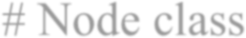  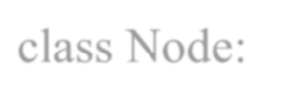  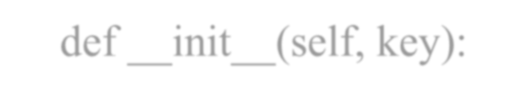  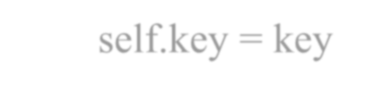  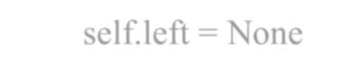  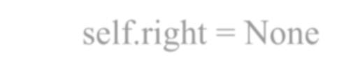  # Node class  class Node:  def init (self, key): self.key = key self.left = None self.right = None  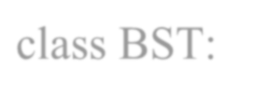  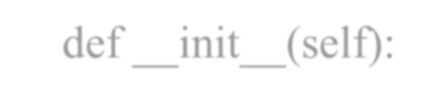  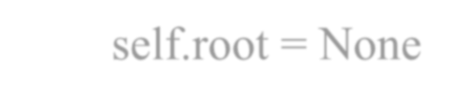  # Binary Search Tree class  class BST:  def init (self): self.root = None  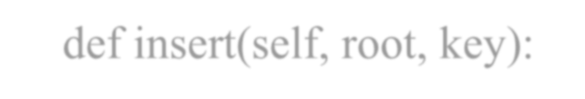  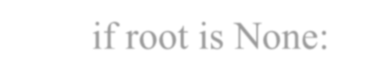  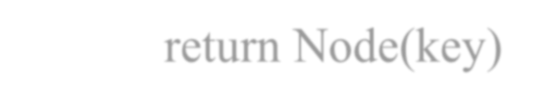  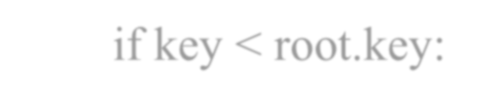  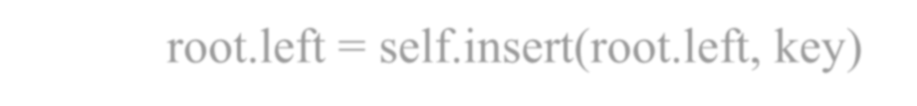  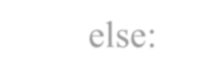  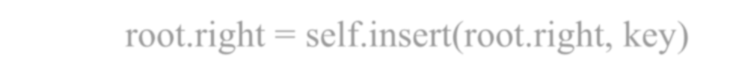  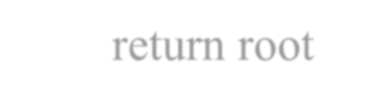  # Insert a node into BST def insert(self, root, key):  if root is None: return Node(key)  if key < root.key:  root.left = self.insert(root.left, key) else:  root.right = self.insert(root.right, key) return root  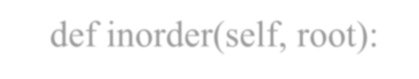  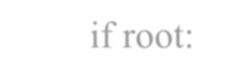  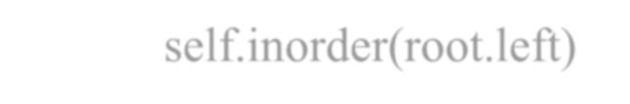  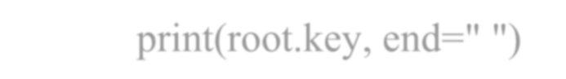  # In-order Traversal (Left → Root → Right) def inorder(self, root):  if root:  self.inorder(root.left) print(root.key, end=" ")

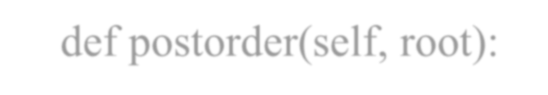
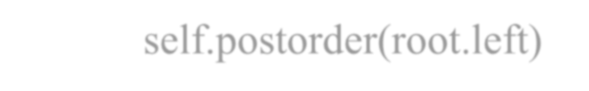
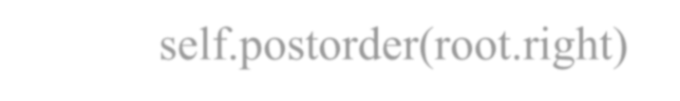
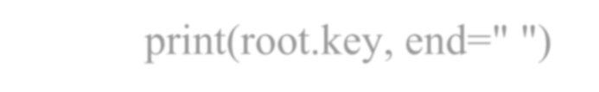
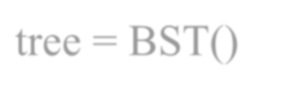
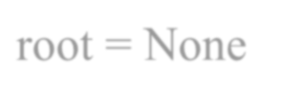
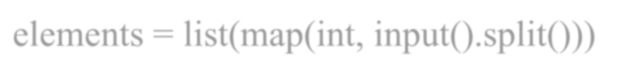
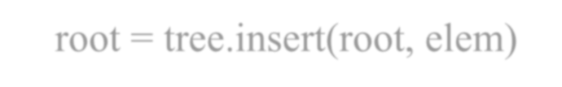
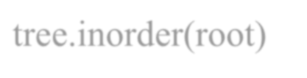
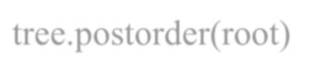
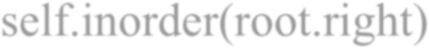
self.inorder(root.right)

# Post-order Traversal (Left → Right → Root)
def postorder(self, root): if root:
self.postorder(root.left) self.postorder(root.right) print(root.key, end=" ")

# -------- Main Program -------- tree = BST()
root = None

print("Enter elements to insert into BST (space-separated):") elements = list(map(int, input().split()))

for elem in elements:
root = tree.insert(root, elem)

print("\nIn-order Traversal:") tree.inorder(root)

print("\nPost-order Traversal:") tree.postorder(root)

Output:
Enter elements to insert into BST (space-separated): 25 75 86 94 52 36 85
In-order Traversal: 25 36 52 75 85 86 94
Post-order Traversal: 36 52 85 94 86 75 25

 | Student Name: : Sanika Krushna Bhagat | Class:MCA-I
 | Program Title: | Date:
 | Remark:
Q12. | write a python program to create BST & print its mirror tree.  # Node class class Node:  def init (self, key): self.key = key self.left = None self.right = None  # Binary Search Tree class class BST:  def init (self): self.root = None  # Insert a node in BST def insert(self, root, key):  if root is None: return Node(key)  if key < root.key:  root.left = self.insert(root.left, key) else:  root.right = self.insert(root.right, key) return root  # Inorder Traversal (Left → Root → Right) def inorder(self, root):  if root:  self.inorder(root.left) print(root.key, end=" ") self.inorder(root.right)

# Mirror of Tree (swap left and right) def mirror(self, root):
if root:
root.left, root.right = root.right, root.left self.mirror(root.left) self.mirror(root.right)
return root

# MAIN PROGRAM
tree = BST() root = None
# Input elements
print("Enter values to insert into BST (space-separated):") elements = list(map(int, input().split()))
# Insert into BST for val in elements:
root = tree.insert(root, val)

# Print original tree
print("\nIn-order Traversal of Original BST:") tree.inorder(root)
# Mirror the tree tree.mirror(root)

# Print mirrored tree
print("\n\nIn-order Traversal of Mirror BST:") tree.inorder(root)
print()

Output:
Enter values to insert into BST (space-separated): 45 65 87 98 28 52 63
In-order Traversal of Original BST: 28 45 52 63 65 87 98

In-order Traversal of Mirror BST: 98 87 65 63 52 45 28

 | Student Name: : Sanika Krushna Bhagat | Class:MCA-I
 | Program Title: | Date:
 | Remark:
Q13. | Write a python program for the following operation on tree-  - Create Binary Search Tree  - Create Mirror of Tree  - Print Only Leaf Nodes  - In-Order Traversal.  # Node class class Node:  def init (self, key): self.key = key self.left = None self.right = None  # Binary Search Tree class class BST:  def init (self): self.root = None  # Insert node  def insert(self, root, key): if root is None:  return Node(key) if key < root.key:  root.left = self.insert(root.left, key) else:  root.right = self.insert(root.right, key) return root  # In-order traversal (Left → Root → Right) def inorder(self, root):  if root:

self.inorder(root.left) print(root.key, end=" ") self.inorder(root.right)

# Print leaf nodes only
def printLeafNodes(self, root): if root:
# If node has no children → leaf node
if root.left is None and root.right is None: print(root.key, end=" ")
self.printLeafNodes(root.left) self.printLeafNodes(root.right)
# Mirror of tree
def mirror(self, root): if root:
root.left, root.right = root.right, root.left self.mirror(root.left) self.mirror(root.right)
return root

#
# MAIN PROGRAM #

tree = BST() root = None

# Input elements
print("Enter values to insert into BST (space separated):") values = list(map(int, input().split()))
# Insert elements for v in values:
root = tree.insert(root, v)

# In-order traversal
print("\nIn-order Traversal of Original Tree:")

tree.inorder(root)

# Print leaf nodes
print("\n\nLeaf Nodes of the Tree:") tree.printLeafNodes(root)
# Mirror of tree tree.mirror(root)

# Print mirrored tree (in-order)
print("\n\nIn-order Traversal of Mirrored Tree:") tree.inorder(root)
print()

Output:
Enter values to insert into BST (space separated): 65 85 96 47 52 31 20
In-order Traversal of Original Tree: 20 31 47 52 65 85 96

Leaf Nodes of the Tree:
20 52 96
In-order Traversal of Mirrored Tree: 96 85 65 52 47 31 20

 | Student Name: : Sanika Krushna Bhagat | Class:MCA-I
 | Program Title: | Date:
 | Remark:
Q14. | Python Program to Convert Infix Expression to Postfix.  def precedence(op):  if op in ('+', '-'): return 1  if op in ('*', '/'): return 2 if op == '^': return 3 return 0  def infix_to_postfix(exp): stack = []  output = ""  for ch in exp:  if ch.isalnum(): output += ch  elif ch == '(': stack.append(ch)  elif ch == ')':  while stack and stack[-1] != '(': output += stack.pop()  stack.pop() else:  while stack and precedence(ch) <= precedence(stack[-  1]):  output += stack.pop() stack.append(ch)  while stack:  output += stack.pop() return output  exp = input("Enter infix expression: ")

print("Postfix expression:", infix_to_postfix(exp))

Output:
Enter infix expression: A+B(C*D)E/F Postfix expression: ABCD*EF/+

 | Student Name: : Sanika Krushna Bhagat | Class:MCA-I
 | Program Title: | Date:
 | Remark:
Q15. | Python Program to Read Adjacency Matrix and Convert
 | It into Adjacency List.
 | n = int(input("Enter number of vertices: "))
 | print("Enter adjacency matrix:")
 | matrix = []
 | for i in range(n):
 | row = list(map(int, input().split()))
 | matrix.append(row)
 | adj_list = {i: [] for i in range(n)}
 | for i in range(n):
 | for j in range(n):
 | if matrix[i][j] == 1:
 | adj_list[i].append(j)
 | print("Adjacency List:")
 | for key in adj_list:
 | print(key, ":", adj_list[key])
 | Output:
 | Enter number of vertices: 4
 | Enter adjacency matrix:
 | 1 0 0 1
 | 0 1 1 0
 | 1 0 1 0
 | 0 1 0 1
 | Adjacency List:
 | 0 : [0, 3]
 | 1 : [1, 2]
 | 2 : [0, 2]
 | 3 : [1, 3]

 | Student Name: : Sanika Krushna Bhagat | Class:MCA-I
 | Program Title: | Date:
 | Remark:
Q16. | Python Program to Create Graph & Traverse Using DFS and BFS.  from collections import defaultdict, deque class Graph:  def init (self):  self.graph = defaultdict(list)  def add_edge(self, u, v): self.graph[u].append(v)  def dfs(self, start, visited=None): if visited is None:  visited = set() visited.add(start) print(start, end=" ")  for node in self.graph[start]: if node not in visited:  self.dfs(node, visited)  def bfs(self, start): visited = set()  queue = deque([start]) visited.add(start)  while queue:  node = queue.popleft() print(node, end=" ")  for adj in self.graph[node]: if adj not in visited:  visited.add(adj) queue.append(adj)

g = Graph()
n = int(input("Enter number of edges: "))

print("Enter edges (u v):") for _ in range(n):
u, v = input().split() g.add_edge(u, v)
start = input("Enter starting vertex: ") print("DFS:", end=" ")
g.dfs(start)
print()
print("BFS:", end=" ") g.bfs(start)
print()

Output:
Enter number of edges: 5 Enter edges (u v):
A B
A C
B D
C E
D F
Enter starting vertex: A DFS: A B D F C E BFS: A B C D E F

 | Student Name: : Sanika Krushna Bhagat | Class:MCA-I
 | Program Title: | Date:
 | Remark:
Q17. | Python Program to Implement Binary Search.  def binary_search(arr, x): low, high = 0, len(arr) - 1  while low <= high:  mid = (low + high) // 2 if arr[mid] == x:  return mid elif x < arr[mid]:  high = mid - 1 else:  low = mid + 1 return -1  arr = list(map(int, input("Enter sorted elements: ").split())) x = int(input("Enter element to search: "))  pos = binary_search(arr, x) if pos != -1:  print("Element found at index", pos)  else:  print("Element not found")  Output:  Enter sorted elements: 70 25 65 48 96 35 20 Enter element to search: 25  Element found at index 1  Enter sorted elements: 70 25 65 48 96 35 20 Enter element to search: 90  Element not found

 | Student Name: : Sanika Krushna Bhagat | Class:MCA-I
 | Program Title: | Date:
 | Remark:
Q18. | Python Program to Implement Bubble Sort.  def bubble_sort(arr): n = len(arr)  for i in range(n):  for j in range(0, n - i - 1): if arr[j] > arr[j + 1]:  arr[j], arr[j + 1] = arr[j + 1], arr[j]  arr = list(map(int, input("Enter elements: ").split())) bubble_sort(arr)  print("Sorted list:", arr)  Output:

 | Student Name: : Sanika Krushna Bhagat | Class:MCA-I
 | Program Title: | Date:
 | Remark:
Q19. | Python Program to Sort All Elements Using Quick Sort (Recursive).  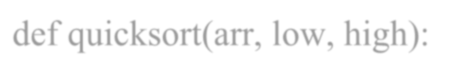  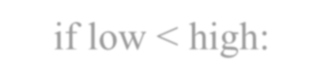  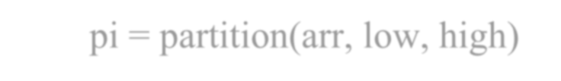  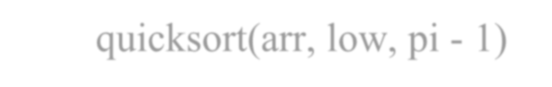  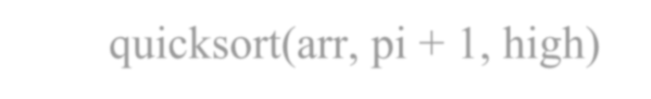  def quicksort(arr, low, high): if low < high:  pi = partition(arr, low, high) quicksort(arr, low, pi - 1) quicksort(arr, pi + 1, high)  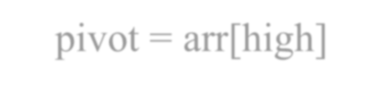  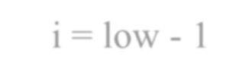  def partition(arr, low, high): pivot = arr[high]  i = low - 1  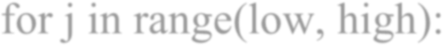  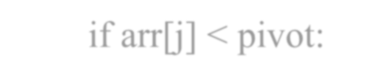  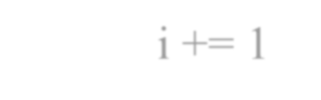  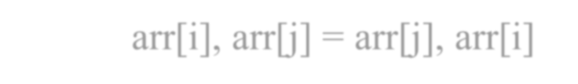  for j in range(low, high): if arr[j] < pivot:  i += 1  arr[i], arr[j] = arr[j], arr[i]  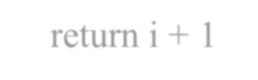  arr[i + 1], arr[high] = arr[high], arr[i + 1]  return i + 1  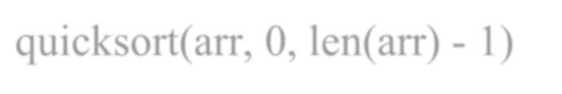  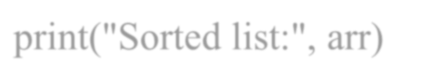  arr = list(map(int, input("Enter elements: ").split())) quicksort(arr, 0, len(arr) - 1)  print("Sorted list:", arr)  Output:  Enter elements: 90 45 06 8 02 95 20 31  Sorted list: [2, 6, 8, 20, 31, 45, 90, 95]

 | Student Name: : Sanika Krushna Bhagat | Class:MCA-I
 | Program Title: | Date:
 | Remark:
Q20. | Write a Python program to implement Heap Sort.  def heapify(arr, n, i): largest = i  left = 2 * i + 1 right = 2 * i + 2  # Check if left child is larger  if left < n and arr[left] > arr[largest]: largest = left  # Check if right child is larger  if right < n and arr[right] > arr[largest]: largest = right  # If largest is not root if largest != i:  arr[i], arr[largest] = arr[largest], arr[i] heapify(arr, n, largest)  def heap_sort(arr): n = len(arr)  # Build max heap  for i in range(n // 2 - 1, -1, -1): heapify(arr, n, i)  # Extract elements  for i in range(n - 1, 0, -1):  arr[i], arr[0] = arr[0], arr[i] # Swap

heapify(arr, i, 0)

# Example usage
arr = [12, 11, 13, 5, 6, 7]
heap_sort(arr) print("Sorted array:", arr)

Output:
Sorted array: [5, 6, 7, 11, 12, 13]

 | Student Name: : Sanika Krushna Bhagat | Class:MCA-I
 | Program Title: | Date:
 | Remark:
Q21. | Write a Python program to print all interior (non-leaf)
 | nodes of a tree.
 | class Node:
 | def init (self, data):
 | self.data = data
 | self.left = None
 | self.right = None
 | def print_interior_nodes(root):
 | if root is None:
 | return
 | # If NOT a leaf node, print it
 | if root.left is not None or root.right is not None:
 | print(root.data, end=" ")
 | print_interior_nodes(root.left)
 | print_interior_nodes(root.right)
 | # Example Tree
 | # 10
 | # / \
 | # 5 20
 | # / \ /
 | # 3 7 15
 | root = Node(10)
 | root.left = Node(5)
 | root.right = Node(20)
 | root.left.left = Node(3)

root.left.right = Node(7) root.right.left = Node(15)

print("Interior (non-leaf) nodes:") print_interior_nodes(root)

Output:
Interior (non-leaf) nodes: 10 5 20

